Exercise 1: Setting Up JUnit (MANDATORY)

- Project Creation: Created a project
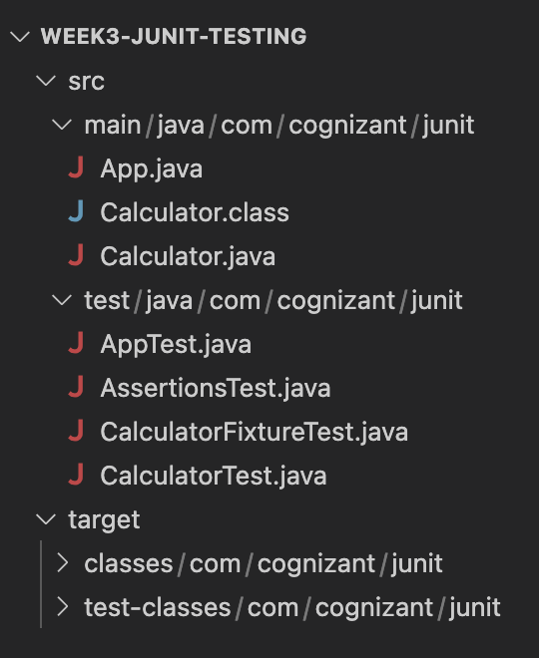

- Adding JUnit Dependencies: pom.xml file with added dependencies

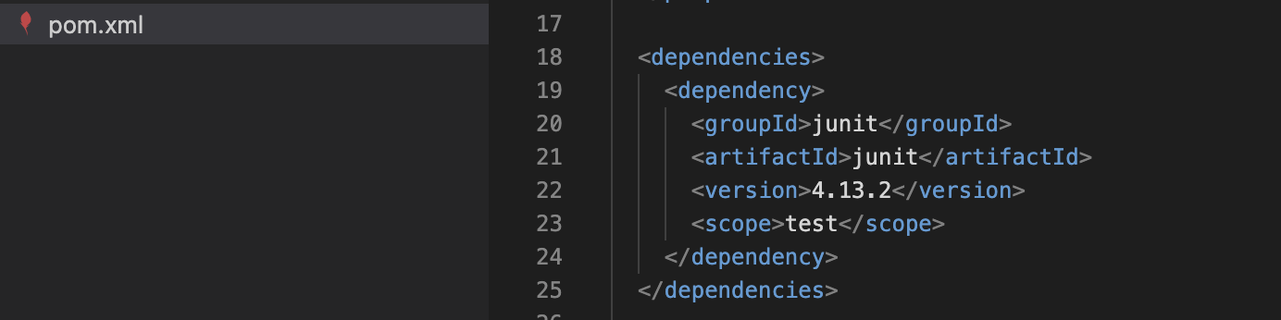

- Create a new test class in your project: Adding AppTest.java file

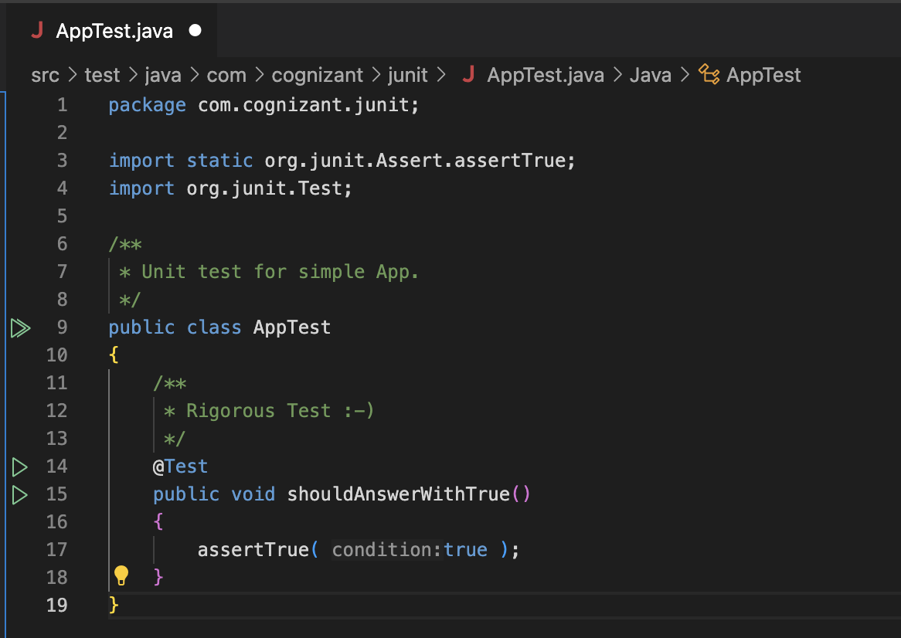
Exercise 3: Assertions in JUnit (MANDATORY)

AssertionsTest.java Code: Write tests using various JUnit assertions.

package com.cognizant.junit;
import static org.junit.Assert.assertEquals;
import static org.junit.Assert.assertFalse;
import static org.junit.Assert.assertNotNull;
import static org.junit.Assert.assertNull;
import static org.junit.Assert.assertTrue;
import org.junit.Test;
public class AssertionsTest {
@Test
public void testAssertions() {
assertEquals("Sum should be 5", 5, 2 + 3);
assertTrue("5 should be greater than 3", 5 > 3);
assertFalse("3 should not be greater than 5", 3 > 5);
String nullStr = null;
assertNull("Should be null", nullStr);
String notNullStr = "JUnit";
assertNotNull("Should not be null", notNullStr);
}
}

Output:
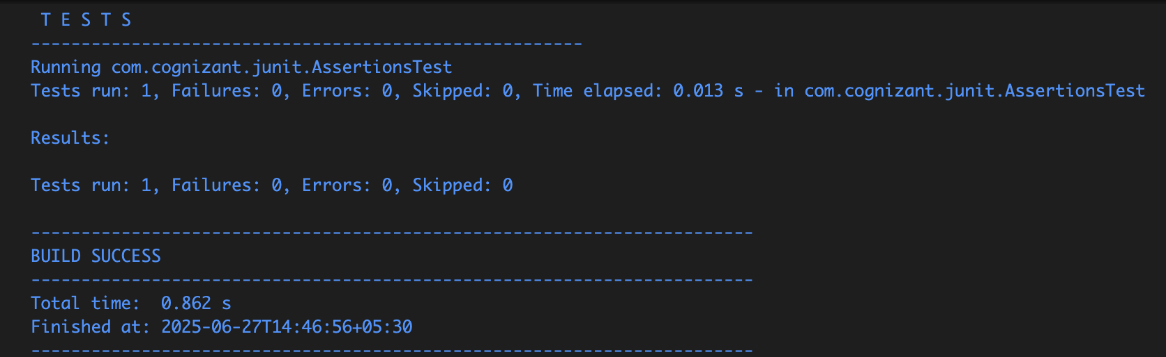

Running all assertions:
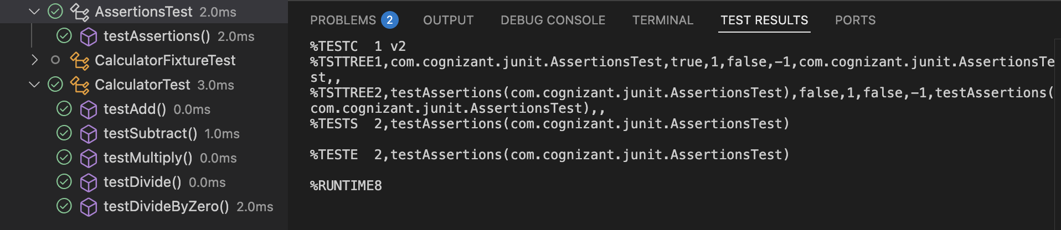

Exercise 4: Arrange-Act-Assert (AAA) Pattern, Test Fixtures, Setup and
Teardown Methods in JUnit (MANDATORY)

Created a test class CalculatorFixtureTest.java to demonstrate the Arrange-Act-Assert (AAA) pattern and the use of @Before and @After methods in JUnit.

package com.cognizant.junit;
import org.junit.After;
import static org.junit.Assert.assertEquals;
import org.junit.Before;
import org.junit.Test;
public class CalculatorFixtureTest {
private Calculator calculator;
@Before
public void setUp() {
System.out.println("Setting up Calculator instance...");
calculator = new Calculator();
}
@After
public void tearDown() {
System.out.println("Cleaning up after test...\n");
calculator = null;
}
@Test
public void testAdditionAAA() {
int a = 10, b = 5;
int result = calculator.add(a, b);
assertEquals("Addition should be 15", 15, result);
}
@Test
public void testMultiplicationAAA() {
int a = 3, b = 4;
int result = calculator.multiply(a, b);
assertEquals("Multiplication should be 12", 12, result);
}
}

Output:
